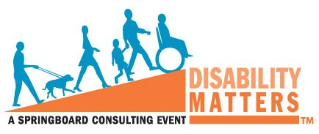
Disability Matters Attendees ONLY: Special Offer
Springboard now offers Disability Matters registrants only, the opportunity to purchase a DVD of this event to share with colleagues across your organization.

No matter how many attend the 2014 Disability Matters North America Conference and Awards, there will be so many more who wished they could have been there. Although there is nothing like being at this most important event, there is a way to still share the immense educational information, inspirational stories and honoree celebrations that you will experience as an attendee.
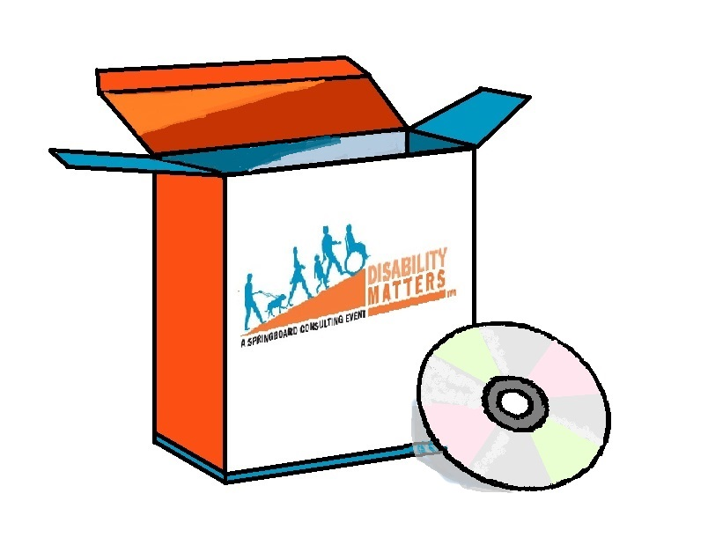
Order the conference DVD which includes the honoree panels, specialty sessions, welcome and closing remarks and keynote presentations, before April 1st for the low price of $199.00 which is a substantial discount off the regular price (purchases after 4/1/2014) of $325. Order today by visiting >>http://www.consultspringboard.com/disability-matters/dmus2014/2014dmna-video-purchase/
ABOUT SPRINGBOARD CONSULTING®
Founded in 2005, Springboard is recognized as the expert in mainstreaming disability in the global workforce, workplace and marketplace. Serving corporations and organizations throughout the U.S., Canada, Europe and Asia, Springboard has become a trusted partner in relation to disability issues and initiatives across virtually every business category. Springboard annually honors exemplary organizational initiatives that promote the outreach, support & engagement of people with disabilities as employees and as consumers through the Disability Matters Awards.

